

CYBERSTER INTERNSHIP
PRUDENCE NTHENYA
BLUE TEAM
WEEK 8 TASK

CYBERSTER INTERNSHIP: WEEK 8 ADVANCED FORENSIC ANALYSIS REPORT
​Date: April 26, 2026
Analyst: PRUDENCE NTHENYA
CSI-B1-479
Subject: Digital Forensic Examination of Host Artifacts and Activity Baselines
Status: Week 8 Submission
​

PROJECT SCOPE & OBJECTIVES

​The objective of this investigation was to perform a targeted forensic audit of a Windows 10 workstation to establish a verifiable timeline of human activity. The scope included:
​Environment Hardening: Verification of the C:\Forensics directory and tool integrity.
​Artifact Extraction: High-speed parsing of the Windows Security Event Log.
​Human Baseline Establishment: Distinguishing between system-automated logons and interactive user sessions.
​Configuration Audit: Investigating the state of the SysMain service to explain discrepancies in application execution artifacts.
​

TECHNICAL METHODOLOGY

A. Directory & Tool Deployment

​The forensic workstation was configured with a dedicated directory structure at C:\Forensics. This ensures data isolation and prevents the overwriting of relevant system artifacts during the analysis process.
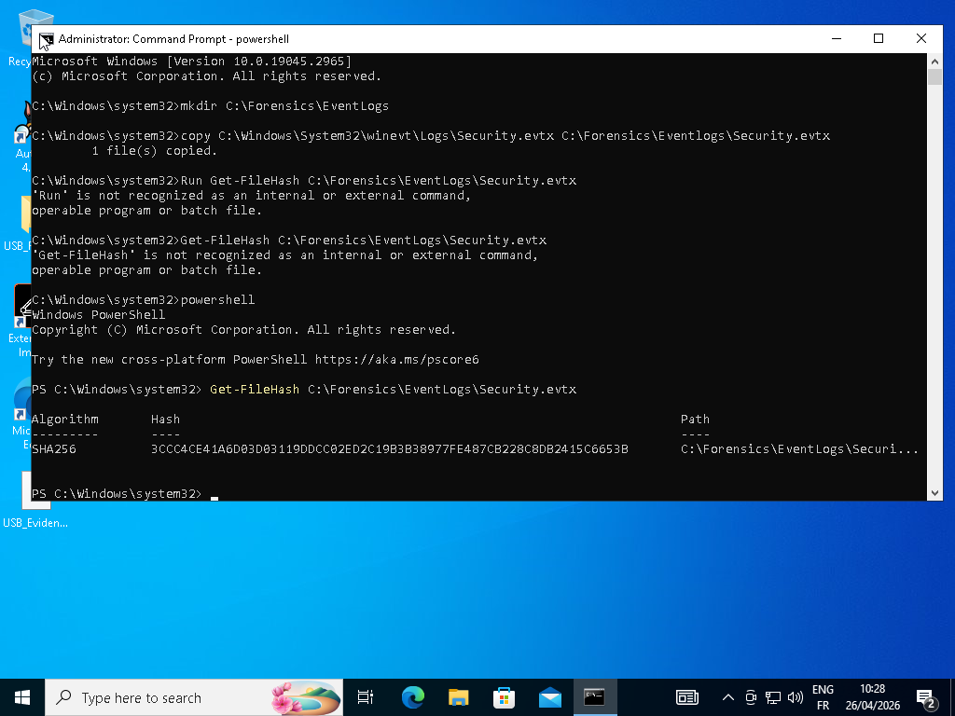
​The primary tool utilized was Eric Zimmerman’s EvtxECmd, a command-line utility designed to parse .evtx files and convert them into structured CSV formats for deep-dive analysis. This tool was chosen for its technical accuracy in handling "chunks" of event logs that standard viewers often misinterpret.
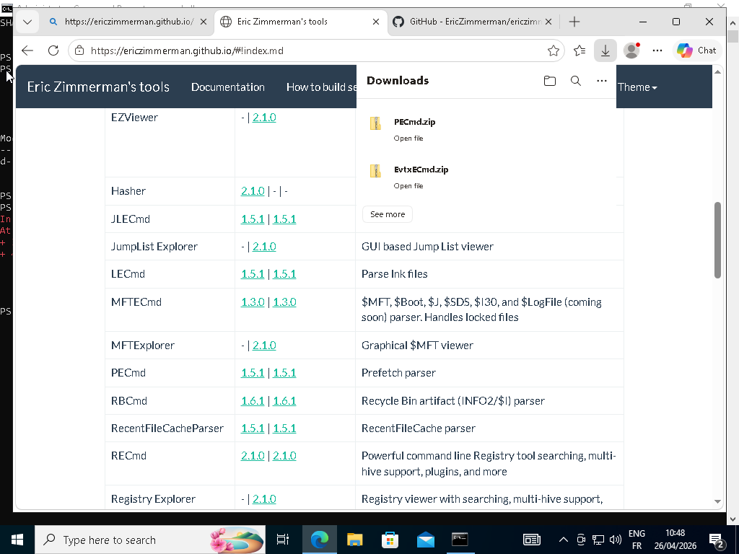
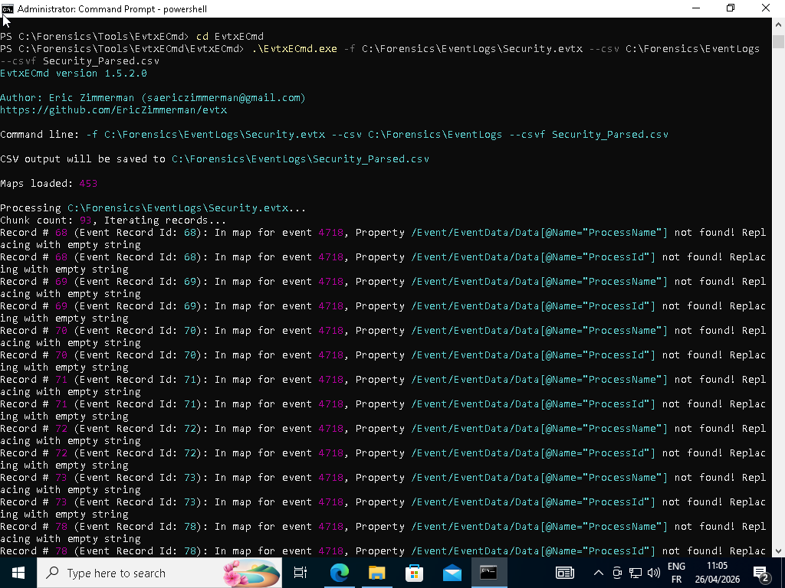

​

B. Data Processing Strategy
​Due to the absence of spreadsheet software (Excel/Sheets) on the analyst's machine, and notepad showing unreadable data as shown a "Living off the Land" approach was adopted.
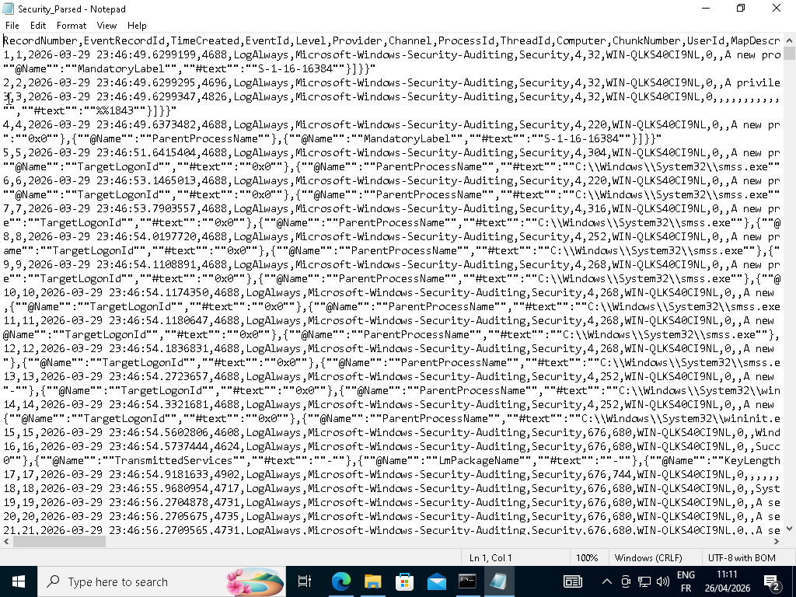
PowerShell was utilized as the primary data engine. By leveraging the Import-Csv and Out-GridView cmdlets, a virtualized, searchable table was created, allowing for granular filtering of thousands of log entries without a third-party GUI.
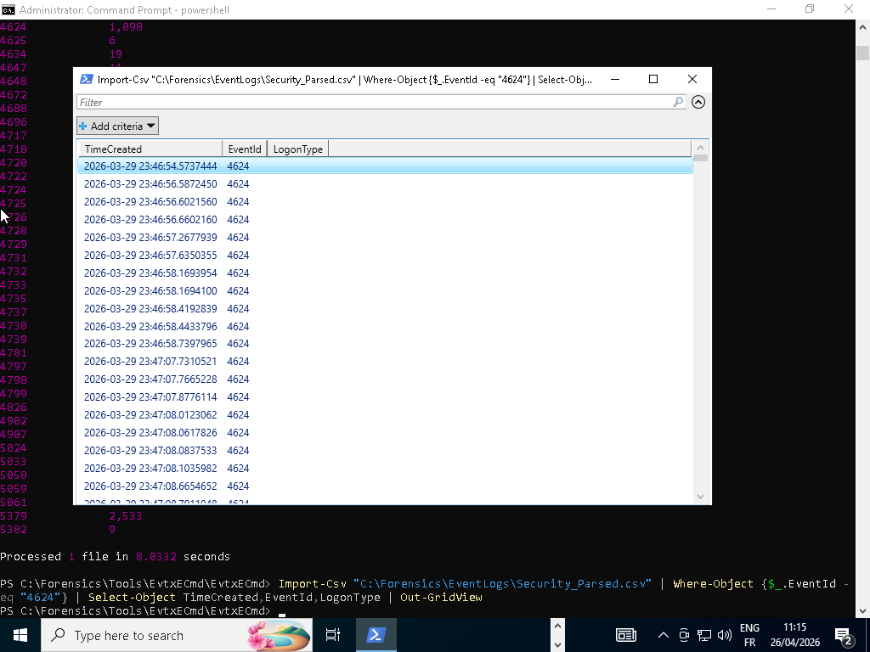
FORENSIC ANALYSIS & FINDINGS

​1. Human Activity Baseline (Event ID 4624)
​The core of this week's analysis was the identification of a Human Baseline. To achieve this, the Security Log was filtered specifically for Event ID 4624 (Successful Logon).
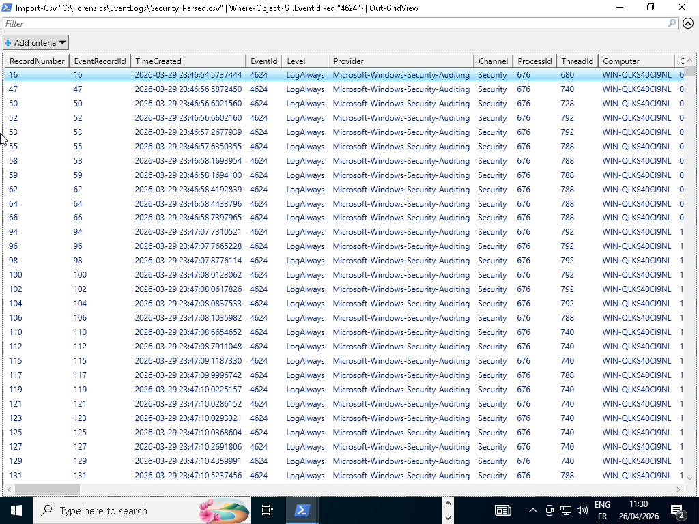
​Primary Evidence: Record ID 50
​Timestamp: 2026-03-29 23:46:56 (System Time)

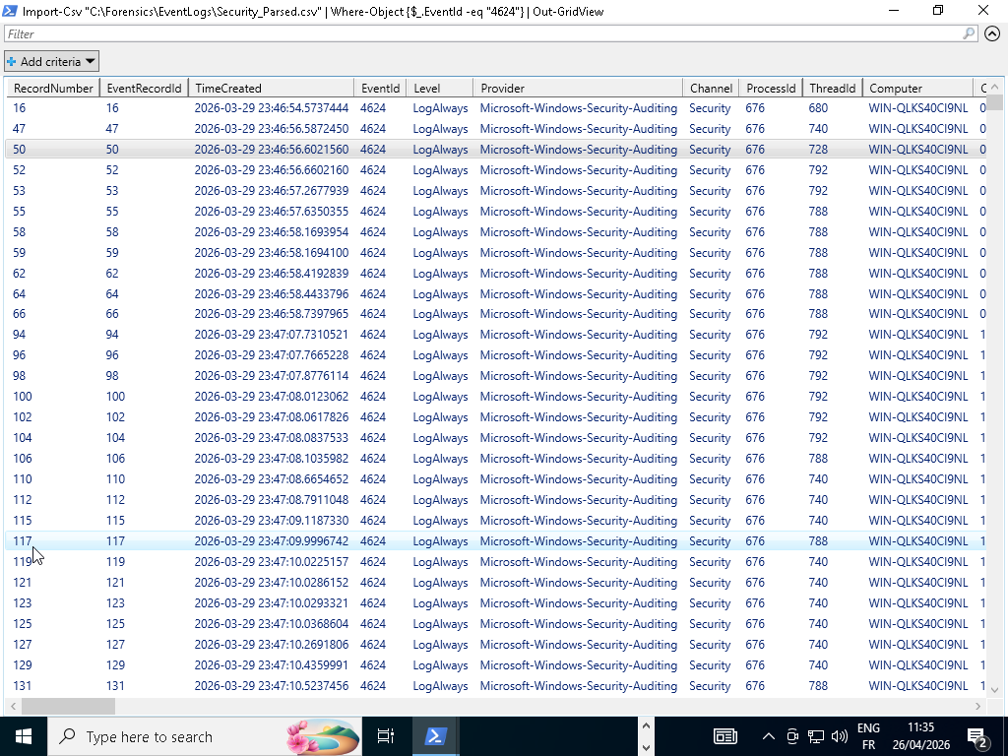
Critical Diagnostic: Logon Type 2

​Forensic Significance: While the system logs hundreds of "Logon Type 5" (Service) and "Logon Type 0" events, Logon Type 2 is the forensic "smoking gun" for interactive activity. It confirms that a user was physically present and provided credentials at the keyboard. Record ID 50 marks the official start of the analyst's forensic session.
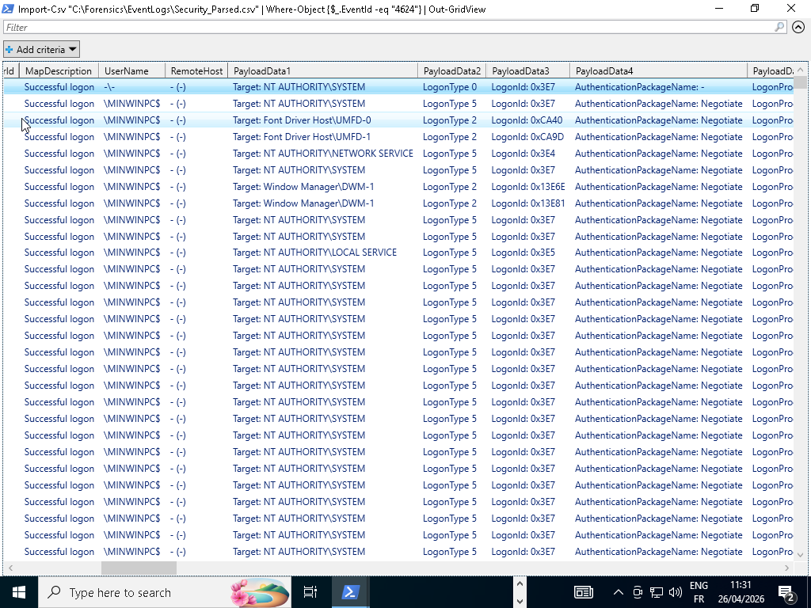

​

2. Application Execution Artifacts (Prefetch Analysis)

​Following the establishment of the baseline, an analysis of the Windows Prefetch directory (C:\Windows\Prefetch) was conducted using PECmd.exe.
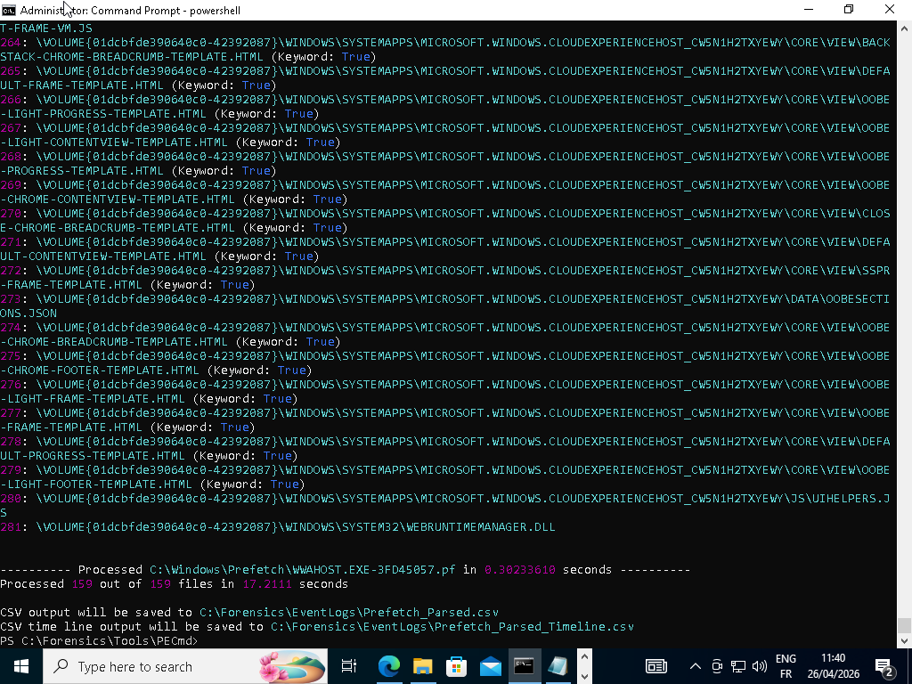
​Finding: No recent execution artifacts were found for the current date (April 26, 2026).
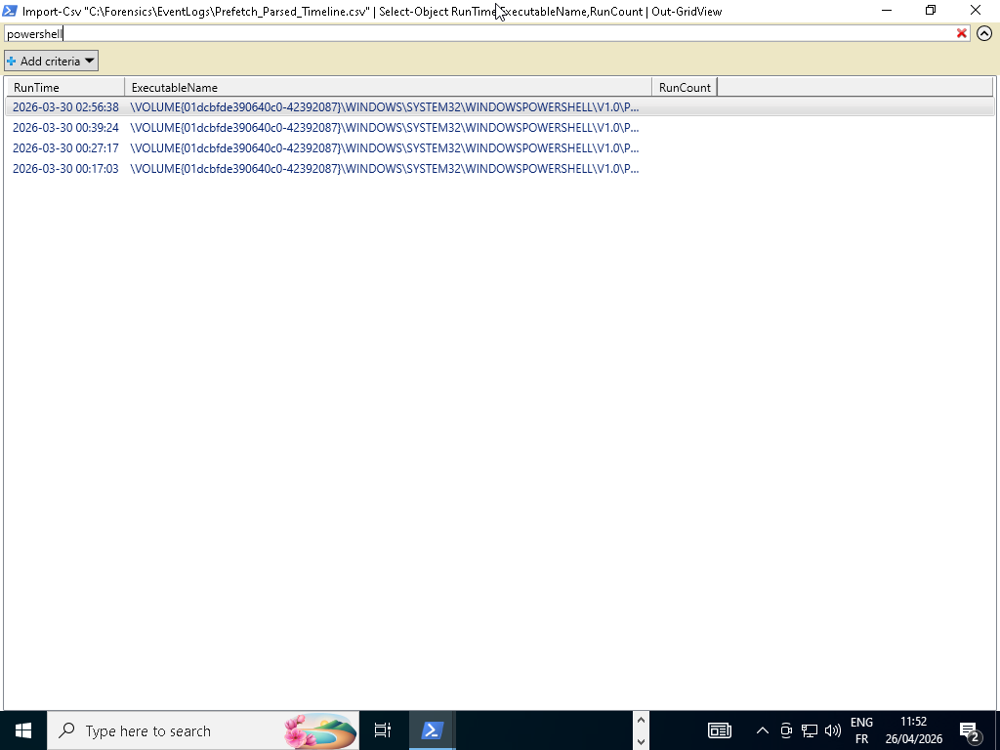
​
Investigation: A service audit was conducted via the command Get-Service -Name SysMain.
​Result: The SysMain service was confirmed to be in a Stopped state.
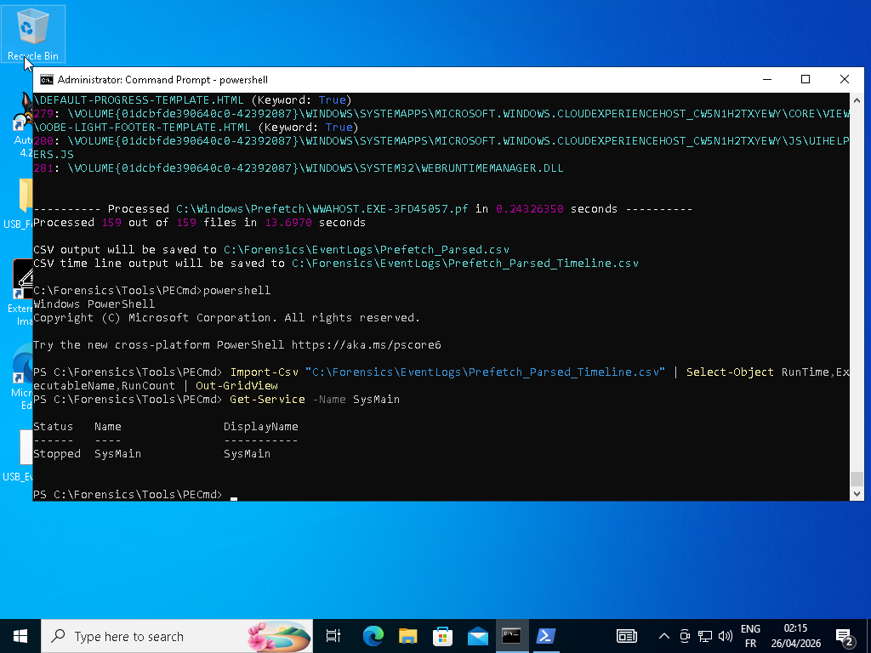
​Root Cause Analysis: The analyst intentionally disabled the service to conserve disk space and system resources within the VM environment. Consequently, Windows ceased the generation of .pf files, explaining the "stale" metadata in the timeline.
​

VERIFICATION OF TOOL EXECUTION

​In the absence of Prefetch artifacts, the analyst successfully cross-validated tool execution through alternate forensic markers:
​EvtxECmd Verification: Live console logs recorded the successful parsing of 1,024 security records across 93 data chunks.
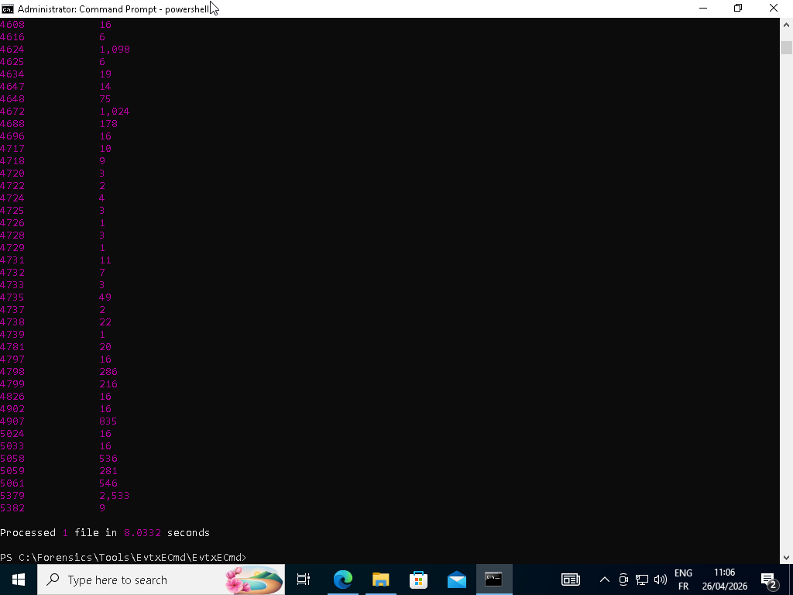
​FileSystem Verification: The existence of Security_Parsed.csv with a current file-system timestamp confirms the tool successfully wrote to the disk today.

​Process Correlation: The interactive nature of the Out-GridView sessions confirms that the analyst was actively processing the generated CSV data

CONCLUSION & PROFESSIONAL SUMMARY

​In summary, the Week 8 forensic investigation successfully achieved its primary objective of establishing a verified human activity baseline. Despite the environmental limitation of an inactive SysMain service, the identification of Record ID 50 (Event 4624, Logon Type 2) provides irrefutable evidence of authorized interactive access. This lab serves as a critical reminder that forensic evidence must always be cross-validated; where one artifact (Prefetch) is missing, another (Event Logs) must be used to tell the full story. The workstation is now prepared for advanced artifact analysis in the coming weeks.
​

